**PROJECT DOCUMENTATION**

**Natural Disasters Intensity Analysis and Classification Using Artificial Intelligence.**

**1.INTRODUCTION:**

**1.1 Project Overview:**

Natural Disasters are catastrophic events with atmospheric and historic origins (hurricanes, floods, tsunamis, earthquakes). That can cause fatalities, property damage and social environment disruption.

Natural disasters are the results of a hazard overwhelming highly vulnerable community,often resulting in mortality and morbidity.Over the past decade,over 300 natural disasters occur yearly around the world affecting millions and cost billions.The disaster cycle is a framework used to base a coordinated plan to respond,recover,prevent,and prepare for a disaster.Access to clean water,proper sanitation,food/nutrition,shelter,and the threat of communicable diseases are concerns that have potential to be detrimental to the management of a natural disaster,slowing the recovery process.

Natural disasters not only disturb the human ecological system but also destroy the properties and critical infrastructures of human societies and even lead to permanent change in the ecosystem. Disaster can be caused by naturally occurring events such as earthquakes, cyclones, floods, and wildfires. Many deep learning techniques have been applied by various researchers to detect and classify natural disasters to overcome losses in ecosystems, but detection of natural disasters still faces issues due to the complex and imbalanced structures of images. To tackle this problem, we developed a multilayered deep convolutional neural network model that classifies the natural disaster and tells the intensity of disaster of natural The model uses an integrated webcam to capture the video frame and the video frame is compared with the Pre-trained model and the type of disaster is identified and showcased on the OpenCV window.

**1.2 Purpose:**

Basically the main objective of natural disaster management is to reduce the damage. However, there are several objectives that are integrated with it. Those are,

1. Identifying the hazard and its cause.

2. Reducing vulnerability and potential losses of hazard.

3. Assessing, reviewing and controlling the risk.

4. Applying efficient, effective, sustainable relief (food, shelter and money), medical and other facilities in disaster affected people thus they can survive.

5. Reducing the damage, death, sufferings and destruction of any natural and human induced disaster.

6. Giving protection to victims.

7. Increasing the strength among people to survive against disasters.

8. Building up capacity in every sector like- individual, social, economic, environmental, regional, national and international.

9. Ensuring the availability of local emergency equipment and transportation.

10.Promote the culture of disaster risk prevention and mitigation at all levels.

**2. LITERATURE SURVEY:**

**2.1 Existing problem:**

Natural disasters not only disturb the human ecological system but also destroy the properties and critical infrastructures of human societies and even lead to permanent change in the ecosystem. Disaster can be caused by naturally occurring events such as earthquakes, cyclones, floods, and wildfires. Many deep learning techniques have been applied by various researchers to detect and classify natural disasters to overcome losses in ecosystems, but detection of natural disasters still faces issues due to the complex and imbalanced structures of images.

**2.2 References:**

[1] “Number of reported disasters by type.” [Online]. Available: <https://ourworldindata.org/natural-disasters>.

[2] Tuswadi and T. Hayashi, “Disaster Prevention Education in Merapi Volcano Area Primary Schools: Focusing on Students’ Perception and Teachers’ Performance,” Procedia Environ. Sci., vol. 20, pp. 668–677, 2014.

[3] “2015_43291_Sendaiframeworkfordrren_Disaster Reduction 2015-2030,” 2015.

[4] S. Goswami, S. Chakraborty, S. Ghosh, A. Chakrabarti, and B. Chakraborty, “A review on application of data mining techniques to combat natural disasters,” Ain Shams Eng. J., vol. 9, no. 3, pp. 365–378, 2018.

[5] I. A. T. Hashem, I. Yaqoob, N. B. Anuar, S. Mokhtar, A. Gani, and S. Ullah Khan, “The rise of ‘big data’ on cloud computing: Review and open research issues,” Inf. Syst., vol. 47, pp. 98–115, 2015.

[6] M. Yu, C. Yang, and Y. Li, “Big Data in Natural Disaster Management: A Review,” Geosciences, vol. 8, no. 5, p. 165, 2018.

[7] P. Sciences, “science direct,” 2018. [Online]. Available: https://www.sciencedirect.com/.

[8] Springer, “springeropen,” Technolo, 2018. [Online]. Available: <https://www.springeropen.com/journals>.

[9] IEEE, “IEEE,” 2018. [Online]. Available: <http://ieeexplore.ieee.org>.

[10] Google Scholar, “Google Scholar,” 2018. [Online]. Available: <https://scholar.google.com/intl/en/scholar/about.html>

**2.3 Problem Statement Definition:**

The purpose of the problem statement is to identify the issue that is a concern and focus it in a way that allows it to be studied in a systematic way. It defines the problem and proposes a way to research a solution, or demonstrates why further information is needed in order for a solution to become possible.

Problem Statement is inclusive of below answers:

* Who does it affect/does not affect?
* What does it affect/does not affect?
* How does it affect/does not affect?
* When is it a problem/is not a problem.
* Where is it a problem/is not a problem.

Natural disasters not only disturb the human ecological system but also destroy the properties and critical infrastructures of human societies and even lead to permanent change in the ecosystem. Disaster can be caused by naturally occurring events such as earthquakes, cyclones, floods, and wildfires. Many deep learning techniques have been applied by various researchers to detect and classify natural disasters to overcome losses in ecosystems, but detection of natural disasters still faces issues due to the complex and imbalanced structures of images.

The natural disasters disturbs the ecosystem,both humans and animals.(WHO)

In a disaster, **you face the danger of death or physical injury**. You may also lose your home, possessions, and community. Such stressors place you at risk for emotional and physical health problems. Stress reactions after a disaster look very much like the common reactions seen after any type of trauma.(WHAT)

**Wildlife can be killed by the force of the disaster or impacted indirectly through changes in habitat and food availability**. Endangered species are especially vulnerable when habitat is destroyed. Water quality is impacted when sewage treatment facilities flood or debris enters reservoirs and waterways.(HOW)

Natural disasters generally constitute an emergency since **they require immediate intervention due to their high impact on human health and safety**; they affect the normal functioning of working infrastructure, interrupting normal day activities and representing a risk for residents and workers in affected areas.(WHEN)

An area is defined as a hazard prone area **if the mortality risk is higher than a certain threshold**. A cyclone is defined as a wind storm with a maximum speed of more than 64 knots per hour. The definition includes typhoons and hurricanes.(WHERE)

| **Problem Statement (PS)** | **I am (Customer)** | **I’m trying to** | **But** | **Because** | **Which makes me feel** |
| --- | --- | --- | --- | --- | --- |
| PS-1 | Human(People) | Avoid the natural disaster | Due to natural disasters, there are droughts, economic crises, capital destruction etc. | Natural disasters are increasing because of population growth,Urbanisation(a lot of people in small places), alteration of the natural environment(man-made islands) | Natural disasters affect human life and destroy natural resources. |

**3 IDEATION & PROPOSED SOLUTION:**

**3.1 Empathy Map Canvas:**

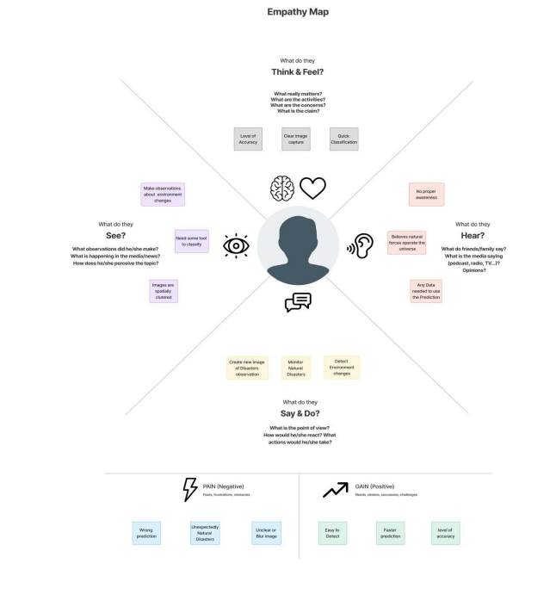

**3.2 Ideation & Brainstorming:**

# 

# **Cyclone intensity evaluation:**

### An application of state-of-art neuroevolution method can be developed for prediction of wind-intensity for tropical cyclones in the South Pacific region. The method employed data from cyclone wind-intensity taken for the last three decades. This employs Cooperative Coevolution method for training Elman recurrent neural networks for the prediction.

# **Flood intensity evaluation:**

### A hybrid deep learning based flood forecasting can be developed. This approach has been made use of daily lagged IF and precipitation time series data to determine flood situations at multiple forecast horizons. The practicality of the model can be tested using datasets from nine locations in Fiji.

### **Storm intensity evaluation:**

### A storm scale ensemble post-processing system based on ensemble machine learning algorithms, radar mosaic verification, and ensemble variable statistics can provide improved precipitation forecasts. Multiple machine learning models of varying complexity were applied to forecasts. Probabilistic, deterministic, and interval forecasts of 1-hour precipitation accumulation were created with the different models. Verification statistics showed that random forests, multiple logistic regression, and MARS provided significant improvements for probabilistic and continuous forecasts by both increasing the range of precipitation and probabilistic values predicted and by increasing the areal coverage of the precipitation forecasts.

**3.3 Proposed Solution:**

| **S.NO.** | **PARAMETER** | **DESCRIPTION** |
| --- | --- | --- |
| 1. | Problem statement(Problem to be solved) | A natural disaster is the negative impact following an actual occurrence of natural hazard in the event that it significantly harms a community. A natural disaster can cause loss of life or damage property, and typically leaves some economic damage in its wake.Thus this involves finding and classifying the natural disaster and analyzing its intensity. |
| 2. | Idea/Solution description | The main purpose of this model is to detect and classify the type of disaster with high accuracy.To tackle this problem, we developed a multilayered deep convolutional neural network model that classifies the natural disaster and tells the intensity of disaster of natural The model uses an integrated webcam to capture the video frame and the video frame is compared with the Pre-trained model and the type of disaster is identified and showcased on the OpenCV window. |
| 3. | Novelty/Uniqueness | The detection of natural disasters by using deep learning still faces various issues due to imbalance problems.Hear the proposed model provides an effective solution.The solution provides high accuracy and provides better performance. |
| 4. | Social Impact/Customer Satisfaction | Disaster alerts could be done prior so as to avoid unpredictable changes in the environment.Disasters take many shapes,during and immediately after an emergency, disaster management focuses on delivering help and interventions that can save lives of the people, safeguard health, and protect buildings, animals, and community property. |
| 5. | Business Model(Revenue Model) |  |
| 6. | Scalability of the Solution | The analysis of the natural disaster and classification helps in making effective decisions on preventing the loss of lives and helps in preparation for the upcoming inevitable disaster which could be handled in the future. |

**3.4 Proposed Solution fit**

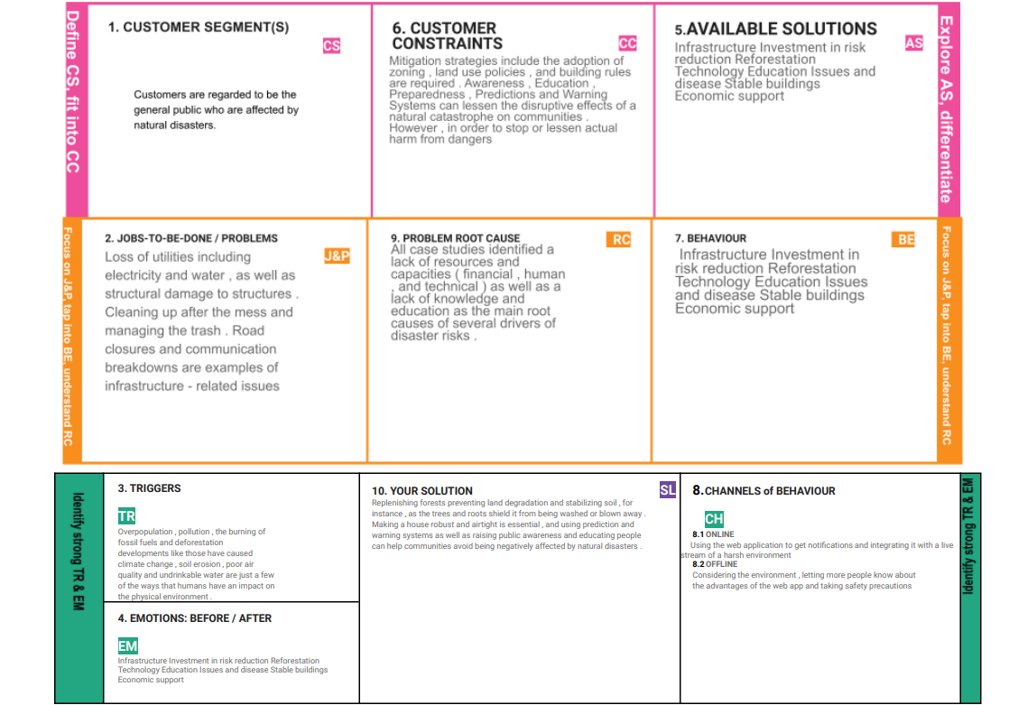

**4. REQUIREMENT ANALYSIS**

**4.1 Functional requirement:**

Following are the functional requirements of the proposed solution.

| **FR No.** | **Functional Requirement (Epic)** | **Sub Requirement (Story / Sub-Task)** |
| --- | --- | --- |
| FR-1 | **User Registration** | * Registering via Google Accounts * Registering via Product's own user management system |
| FR-2 | **User Authentication** | • Verification through OTP  • Verification through Email Link |
| FR-3 | **Designation of Region** | • Ease of selection of necessary areas to be monitored  • Versatile and Flexible operations an designated areas |
| FR-4 | **Analysis of Required Phenomenon** | • Simple and easy analysis on the specific phenomenon to be observed |
| FR-5 | **Accumulation of required Data** | • Fast and Efficient data gathering capabilities regarding past event analysis and future prediction |
| FR-6 | **Organizing Unstructured data** | • Processing of raw and clustered data into clear and refined data which is useful for analysis and prediction tasks |
| FR-7 | **Algorithm selection** | • The freedom to choose from several classes of algorithm to be used in the process  • Customization of algorithm to suit the needs of a specific purpose |
| FR 8 | **Prediction and analysis of data the process** | • Advanced visualization techniques to help visualize the processed data for effective |
| FR-9 | **Report generation** | • Restructuring of obtained results into clear and detailed report for future studies |

**4.2 Non-functional Requirements:**

Following are the non-functional requirements of the proposed solution.

| **NFR No** | **Non-Functional Requirement** | **Description** |
| --- | --- | --- |
| NRF - 1 | **Usability** | It is well suited for fields requiring diverse application of processes with efficiency. precision and ease. |
| NRF - 2 | **Security** | It provides a distinct and secure encryption layer to the system interface for additional security standards. |
| NRF - 3 | **Reliability** | The product is robust and is capable of execution of processes even in the most difficult and unpredictable environments. |
| NRF - 4 | **Performance** | The product boasts a high precision and efficient working capacity which helps in escalating its performance to the highest degree. |
| NRF - 5 | **Availability** | Despite the complexity and degree of difficulty in its operation, the product is equipped with all-round maintenance and readily available technical services which provides the necessary support any individual requires in their duties. |
| NRF - 6 | **Scalability** | The product also possess enough room for the improvement of its specifications to upgrade its capabilities according to the needs of the user and their organization |

**5. PROJECT DESIGN:**

**5.1 Data Flow Diagrams:**

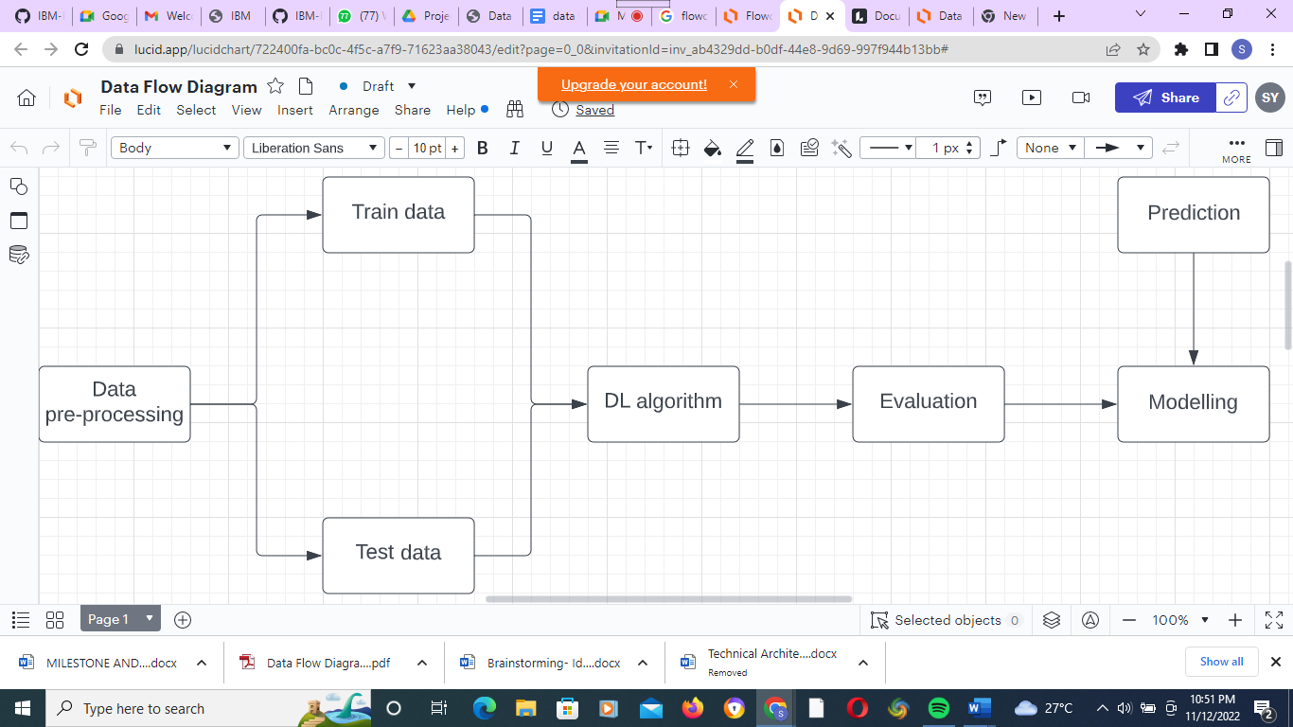

**5.2 Solution & Technical Architecture:**

Solution architecture is a complex process – with many sub-processes – that bridges the gap between business problems and technology solutions. Its goals are to:

* Find the best tech solution to solve existing business problems.
* Describe the structure, characteristics, behavior, and other aspects of the software to project stakeholders.
* Define features, development phases, and solution requirements.
* Provide specifications according to which the solution is defined, managed, and delivered.

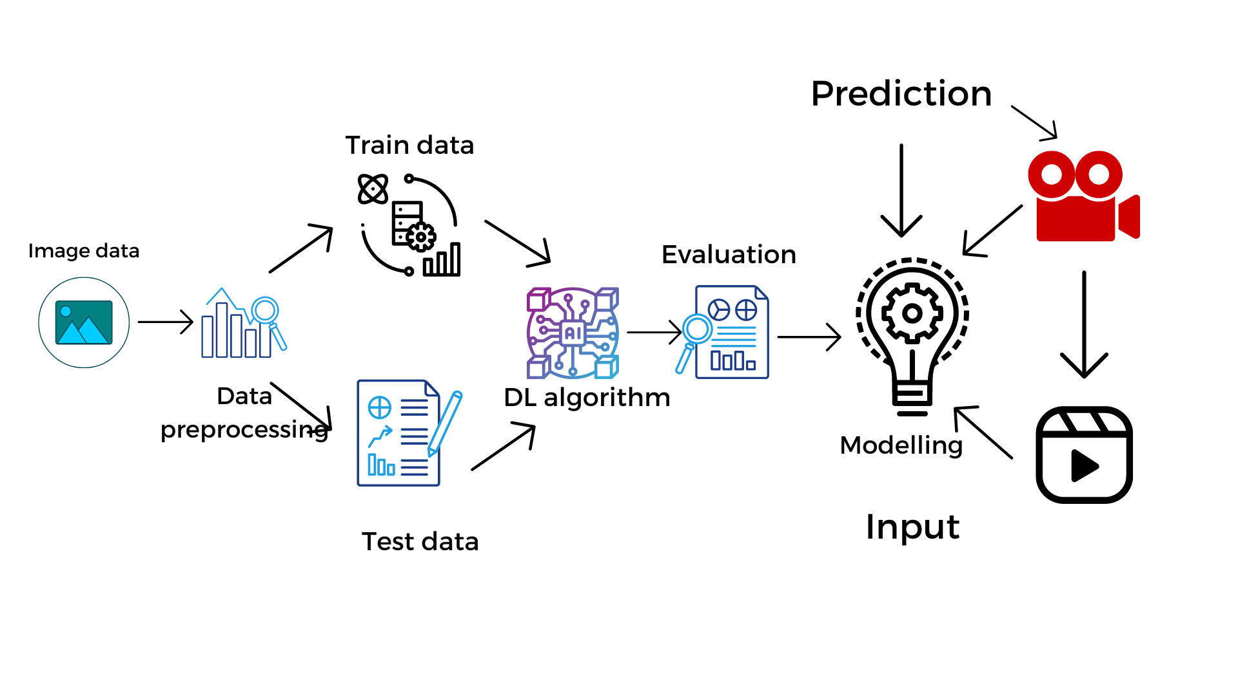

# 

# **Components & Technologies:**

# **1. User Interface**

## **Description**

User interacts with the application for the prediction of Any Natural disaster which will happen in future minutes.

**Technology**

HTML, CSS, JavaScript, Django, Python.

## **2. Feature Engineering Pipeline**

## **Description**

Algorithms can't make sense of raw data. We have to select, transform, combine, and otherwise prepare our data so the algorithm can find useful patterns.

**Technology**

Image processing, pattern extraction, etc.

**3. Model Training kit**

**Description**

It learns patterns from the data. Then they use these patterns to perform particular tasks

**Technology**

Multiclass Classification Model, Regression Model, etc.

**4. Prediction unit**

**Description**

This function is used to predict outcomes from the new trained data to perform new tasks and solve new problems.

**Technology**

Decision trees, Regression, Neural networks.

**5. Evaluation system**

**Description**

It monitors that how Algorithm performs on data as well as during training

**Technology**

Chi-Square, Confusion Matrix, etc.

**6. Interactive services**

**Description**

To interact with our model and give it problems to solve. Usually this takes the form of an API. a user interface or a command-line interface

**Technology**

Application programming interface, etc.

## **7. Data collection unit**

## **Description**

Data is only useful if it's accessible, so it needs to be stored ideally in a consistent structure and conveniently in one place.

**Technology**

IBM Cloud, SQL Server.

## **8. Data generation system**

## **Description**

Every machine learning application lives off data. That data has to come from somewhere. Usually, it's generated by one of your core business functions

**Technology**

Synthetic data generation.

## **9. Database management system**

### **Description**

An organized collection of data stored in a database, so that it can be easily accessed and managed.

**Technology**

MySQL, DynamoDB etc.

**10. IBM Cloud services**

### **Description**

Processed data stored in cloud service which can be access by the admin anywhere over the internet.

**Technology**

IBM Cloud etc.

**Application Characteristics:**

**1. Open-Source Frameworks**

**Description**

An open source framework is a template for software development that is designed by a social network of software developers. These frameworks are free for public use and provide the foundation for building a software application.

**Technology**

Keras, tensor flow.

**2. Authentication**

## **Description**

This keeps our models secure and makes sure only those who have permission can use them.

**Technology**

Encryption and Decryption (OTP).

## **3. Application interface**

### **Description**

User uses mobile application and web application to interact with model

**Technology**

Android and Web Development (PhoneGap, ReactNative, and NativeScript).

## **4. Availability (both Online and Offline work)**

### **Description**

It includes both online and offline work. A good internet connection is needed for online work to explore the software perfectly. Offline work includes the saved data to explore for later time.

**Technology**

Caching, backend server.

## **5. Regular Updates**

### **Description**

The truly excellent software product needs a continuous process of improvements and updates. Maintain your server and make sure that your content is always up-to-date. Regularly update an app and enrich it with new features.

### **Technology**

* Waterfall Approach
* Incremental Approach
* Spiral Approach

## **6. Personalization**

### **Description**

Software has features like flexible fonts, backgrounds settings, colour themes, etc. which make a software interface look good and functional.

**Technology**

* HubSpot
* Proof

# **5.3 User Stories:**

| **User Type** | **Functional Requirement (Epic)** | **User Story Number** | **User Story / Task** | **Acceptance criteria** | **Priority** | **Release** |
| --- | --- | --- | --- | --- | --- | --- |
| Customer (Mobile user) | Upload Data | USN-1 | As a user, I can upload either a live stream, video or photo of the disaster | I can upload the data. | High | Sprint-1 |
| Functional Requirement (Epic) | Obtain Output | USN-2 | As a user, I can receive the classification and the intensity of the disaster | I can receive the information about the disaster | High | Sprint-1 |
| Customer (Mobile user) | Upload Data | USN-1 | As a user, I can upload either a live stream, video or photo of the disaster | I can upload the data. | High | Sprint-1 |
| Customer (Mobile user) | Obtain Output | USN-1 | As a user, I can receive the classification and the intensity of the disaster. | I can receive the information about the disaster | High | Sprint-1 |

# 

**6.PROJECT PLANNING & SCHEDULING:**

**6.1 Sprint Planning and Estimation:**

| **Sprint** | **Functional Requirement (Epic)** | **User Story Number** | **User Story / Task** | **Story Points** | **Priority** | **Team Members** |
| --- | --- | --- | --- | --- | --- | --- |
| Sprint-1 | User input | USN-1 | As a user, I can input the particular URL in the required field and wait for validation. | 2 | High | Kavana Rao,Joe Mariam |
| Sprint-1 | Feature extraction | USN-1 | Here system can extract feature using heuristic and visual similarity approach | 1 | High | Archana,  Saujanya |
| Sprint-1 | Prediction | USN-1 | Here the Model will predict the URL websites using Machine Learning algorithms | 2 | High | Archana,Kavana Rao |
| Sprint-1 | Classifier | USN-1 | Here it will send all the model output to classifier in order to produce final result | 2 | High | Sudharshiny,  Kavana Rao |

| Sprint-1 | Announcement | USN-1 | Displays whether the website is a legal site or a phishing site. | 1 | High | Joe mariam,  Saujanya |
| --- | --- | --- | --- | --- | --- | --- |
| Sprint-2 | Bugs | USN-2 | As a user, I can report bugs in the application | 1 | Medium | Archana,  Sudharshiny |
| Sprint-2 | Feedback | USN-3 | As a user, I can send feedback about the application and opinions for improvement | 1 | Low | Kavana Rao,  Archana |
| Sprint-3 | Tips | USN-4 | Here cyber security tips are provided for the Customers/Users | 1 | Low | Kavana Rao,  JoeMariam. |

**6.2 Sprint Delivery Schedule:**

| **Sprint** | **Total Story Points** | **Duration** | **Sprint Start Date** | **Sprint End Date (Planned)** | **Story Points Completed (as on Planned End Date)** | **Sprint Release Date (Actual)** |
| --- | --- | --- | --- | --- | --- | --- |
| Sprint-1 | 20 | 6 Days | 24 Oct 2022 | 29 Oct 2022 | 20 | 29 Oct 2022 |
| Sprint-2 | 20 | 6 Days | 31 Oct 2022 | 05 Nov 2022 | 20 | 05 Nov 2022 |
| Sprint-3 | 20 | 6 Days | 07 Nov 2022 | 12 Nov 2022 | 20 | 12 Nov 2022 |
| Sprint-4 | 20 | 6 Days | 14 Nov 2022 | 19 Nov 2022 | 20 | 19 Nov 2022 |

# 

# **7 CODING & SOLUTIONING:**

**Feature 1:**

A convolutional neural network is a class of [artificial neural networks](https://en.wikipedia.org/wiki/Artificial_neural_network). It is a Deep Learning algorithm that can take in an input image, assign importance to various objects in the image and be able to differentiate one from the other. The pre-processing required in a ConvNet is much lower as compared to other classification algorithms.

The advantage of CNNs is to provide an efficient dense network which performs the prediction or identification efficiently.

Code is attached below.

**Feature 2:**

We developed a multilayered deep convolutional neural network model that classifies the natural disaster and tells the intensity of disaster of natural The model uses an integrated webcam to capture the video frame and the video frame is compared with the Pre-trained model and the type of disaster is identified and showcased on the OpenCV window. A multilayer neural network with appropriate weights has been shown **to be able to approximate any input-output function making it an attractive tool for modeling and forecasting**.

Code is attached below.

**8. TESTING:**

**8.1 Test Cases**

**8.2 User Acceptance Testing**

This document serves as a quick reference for the Deep Learning Fundus Image Analysis for Early Detection of Diabetic Retinopathy project's test coverage and open issues as of the project's release for user acceptance testing.

**Defect Analysis:-**

This shows how many bugs were fixed or closed at each severity level and how they were fixed.

| **Resolution** | **Severity 1** | **Severity 2** | **Severity 3** | **Severity 4** | **Subtotal** |
| --- | --- | --- | --- | --- | --- |
| By Design | 4 | 5 | 2 | 3 | 14 |
| Duplicate | 1 | 0 | 3 | 1 | 5 |
| External | 2 | 3 | 0 | 1 | 6 |
| Fixed | 9 | 2 | 4 | 15 | 30 |
| Not Reproduced | 0 | 0 | 1 | 0 | 1 |
| Skipped | 1 | 0 | 1 | 1 | 3 |
| Won't Fix | 0 | 5 | 2 | 1 | 8 |
| Totals | 17 | 14 | 13 | 22 | 64 |

# **Test-Case Analysis**

This report shows the number of test cases that have passed, failed, and untested.

| **Section** | **Total Cases** | **Not Tested** | **Fail** | **Pass** |
| --- | --- | --- | --- | --- |
| Print Engine | 9 | 0 | 0 | 9 |
| Client Application | 40 | 0 | 0 | 40 |
| Security | 3 | 0 | 0 | 3 |
| Out-source Shipping | 3 | 0 | 0 | 3 |
| Exception Reporting | 8 | 0 | 0 | 8 |
| Final Report Output | 4 | 0 | 0 | 4 |
| Version Control | 2 | 0 | 0 | 2 |

**9.RESULTS**

**9.1 Performance Metrics:**

| **S.No.** | **Parameter** | **Values(Percentage)** |
| --- | --- | --- |
|  | Model Summary | **-**96% |
|  | Accuracy | Training Accuracy - 96.5%  Validation Accuracy -92.3% |
| 3. | Confidence Score (Only Yolo Projects) | Class Detected - Nil  Confidence Score - Nil |

Our Project marks the successive performance by implementing in order to be cost effective and more reliable to use and to predict the future from the natural disaster that we are ahead of. The successive way includes the objectives, activities and the approaches for the project. It mainly includes the trained dataset which gives an excessive measure of success which helps to overcome the future from this natural disaster.

**10.ADVANTAGES AND DISADVANTAGES**

**ADVANTAGES:**

* The use of AI to forecast natural disasters would save millions of lives. Furthermore, the information evaluated by AI-powered systems can aid in understanding the scale and patterns of natural catastrophes such as floods, earthquakes, and tsunamis, which would aid in improved infrastructure development in disaster-prone areas.
* Disaster management plays an integral role in keeping communities safe. It involves coordinating the resources, such as pollution control systems, and responsibilities, such as following best practice policies, needed to prevent, prepare for, respond to, and recover from emergenci

**DISADVANTAGES:**

* A forest fire is a natural disaster that cannot be forecasted.
* Sometimes the prediction may fail and result in huge loss.

**11. CONCLUSION**

Natural disasters inflict severe damage on almost the entire spectrum of social and natural habitats, ranging from housing and shelter, water, food, health, sanitation, and waste management to information and communication networks, supply of power and energy, and transportation infrastructure. The major challenges faced in all disasters include pre-disaster early warning infrastructure; the supply of food and clean drinking water; health and sanitation; information and communication; power and energy for lighting and cooking; waste collection and disposal, including rapid disposal of dead bodies of humans and animals; disaster-proof housing and shelter; emergency and post-disaster shelters; rescue and relief operations; and transport infrastructure. Though it is not possible to prevent most of the disasters, still their effects can be alleviated or mitigated in magnitude by anticipated preparedness. Advanced disaster management technology could provide a critical support system for disaster management authorities at times of disaster-related crises. Such a technology also provides important inputs for any disaster management plan of action in modern times. Communities and individuals have to be educated on pre-disaster planning and preparedness. Awareness must be created amongst masses, for which first-aid training at grass roots level is essential. There should be a National Disaster Plan that defines the tasks of the communities and local health personnel.

For the evaluation of the model ROC and 30% landslide point’s residual was used. The results showed that the accuracy of the model was estimated by ANFIS in the study area of 77.48% (good accuracy); this data-mining method depends on the number of pairs of training, experimental and fuzzy data used in the research, and, in particular, by increasing the number of fuzzy rules of the process, more accurate simulation can be provided. So far, different methods have been proposed for landslide susceptibility zonation. The accuracy or the error of each of these methods, as well as the use and comparison of each of these methods, requires knowledge of the foundations on which the methods are based. So far, different approaches to landslide susceptibility zonation have been proposed, but what is certain is that all these methods can provide accurate results with minimal data and costs and at very low levels. Combining these models with GIS and [RS](https://www.sciencedirect.com/topics/earth-and-planetary-sciences/remote-sensing) systems not only increases the accuracy of dealing with complex issues and uncertainties, but also leads to the emergence and development of new theories and methods in a variety of issues.

**12.FUTURE SCOPE**

The term “Natural Disaster” encompasses the complete realm of disaster-related activities. Traditionally people tend to think of disaster management only in terms of the post-disaster actions taken by relief and reconstruction officials; yet disaster management covers a much broader scope, and many modern disaster managers may find themselves far more involved in pre-disaster activities than in post-disaster response. Those are:

1. The refugee field of disaster management is highly specialized and requires not only many development skills but also a broader awareness of political, legal, and humanitarian issues.

2. DM aims and objectives, elements, Natural/man-made Disasters, Victims, Relief Systems.

3. Phases of Disaster Response/Relief Operations, Government’s Role.

**To Safeguard and make available vital materials, supplies and equipment to ensure the safety and recovery of records from predictable disasters**.To reduce the risk of disasters caused by human error, deliberate destruction, and building or equipment failures. Be better prepared to recover from a major natural catastrophe.

In this project we help to build preparedness for threats and hazards by providing a low-risk, cost-effective environment to: **Test and validate plans, policies, procedures and capabilities**. Identify resource requirements, capability gaps, strengths, areas for improvement, and potential best practices.

Disaster management aims to reduce, or avoid, the potential losses from hazards, assure prompt and appropriate assistance to victims of disaster, and achieve rapid and effective recovery. Disaster Risk Management includes the sum total of all activities, programmes and measures which can be taken up before, during and after a disaster with the purpose to avoid a disaster, reduce its impact or recover from its losses.

**13. APPENDIX:**

**Source Code**

**home.html:**

<!DOCTYPE html>

<html lang="en">

<head>

<title>Home Page</title>

<meta charset="utf-8">

<meta name="viewport" content="width=device-width, initial-scale=1">

<link rel="stylesheet" href="https://maxcdn.bootstrapcdn.com/bootstrap/3.4.1/css/bootstrap.min.css">

<link href="https://fonts.googleapis.com/css?family=Montserrat" rel="stylesheet" type="text/css">

<link href="https://fonts.googleapis.com/css?family=Lato" rel="stylesheet" type="text/css">

<script src="https://ajax.googleapis.com/ajax/libs/jquery/3.5.1/jquery.min.js"></script>

<script src="https://maxcdn.bootstrapcdn.com/bootstrap/3.4.1/js/bootstrap.min.js"></script>

<style>

body {

font: 400 15px Lato, sans-serif;

line-height: 1.8;

color: #818181;

}

h2 {

font-size: 24px;

text-transform: uppercase;

color: #303030;

font-weight: 600;

margin-bottom: 30px;

}

h4 {

font-size: 19px;

line-height: 1.375em;

color: #303030;

font-weight: 400;

margin-bottom: 30px;

}

.jumbotron {

background-color: #f4511e;

color: #fff;

font-family: Montserrat, sans-serif;

}

.container-fluid {

padding: 60px 50px;

}

.bg-grey {

background-color: #f6f6f6;

}

.logo-small {

color: #f4511e;

font-size: 50px;

}

.logo {

color: #f4511e;

font-size: 200px;

}

.thumbnail {

padding: 0 0 15px 0;

border: none;

border-radius: 0;

}

.thumbnail img {

width: 100%;

height: 100%;

margin-bottom: 10px;

}

.carousel-control.right, .carousel-control.left {

background-image: none;

color: #f4511e;

}

.carousel-indicators li {

border-color: #f4511e;

}

.carousel-indicators li.active {

background-color: #f4511e;

}

.item h4 {

font-size: 19px;

line-height: 1.375em;

font-weight: 400;

font-style: italic;

margin: 70px 0;

}

.item span {

font-style: normal;

}

.panel {

border: 1px solid #f4511e;

border-radius:0 !important;

transition: box-shadow 0.5s;

}

.panel:hover {

box-shadow: 5px 0px 40px rgba(0,0,0, .2);

}

.panel-footer .btn:hover {

border: 1px solid #f4511e;

background-color: #fff !important;

color: #f4511e;

}

.panel-heading {

color: #fff !important;

background-color: #f4511e !important;

padding: 25px;

border-bottom: 1px solid transparent;

border-top-left-radius: 0px;

border-top-right-radius: 0px;

border-bottom-left-radius: 0px;

border-bottom-right-radius: 0px;

}

.panel-footer {

background-color: white !important;

}

.panel-footer h3 {

font-size: 32px;

}

.panel-footer h4 {

color: #aaa;

font-size: 14px;

}

.panel-footer .btn {

margin: 15px 0;

background-color: #f4511e;

color: #fff;

}

.navbar {

margin-bottom: 0;

background-color: #0059ff;

z-index: 9999;

border: 0;

font-size: 12px !important;

line-height: 1.42857143 !important;

letter-spacing: 4px;

border-radius: 0;

font-family: Montserrat, sans-serif;

}

.navbar li a, .navbar .navbar-brand {

color: #fff !important;

}

.navbar-nav li a:hover, .navbar-nav li.active a {

color: #f4511e !important;

background-color: #fff !important;

}

.navbar-default .navbar-toggle {

border-color: transparent;

color: #fff !important;

}

footer .glyphicon {

font-size: 20px;

margin-bottom: 20px;

color: #f4511e;

}

.slideanim {visibility:hidden;}

.slide {

animation-name: slide;

-webkit-animation-name: slide;

animation-duration: 1s;

-webkit-animation-duration: 1s;

visibility: visible;

}

@keyframes slide {

0% {

opacity: 0;

transform: translateY(70%);

}

100% {

opacity: 1;

transform: translateY(0%);

}

}

@-webkit-keyframes slide {

0% {

opacity: 0;

-webkit-transform: translateY(70%);

}

100% {

opacity: 1;

-webkit-transform: translateY(0%);

}

}

@media screen and (max-width: 768px) {

.col-sm-4 {

text-align: center;

margin: 25px 0;

}

.btn-lg {

width: 100%;

margin-bottom: 35px;

}

}

@media screen and (max-width: 480px) {

.logo {

font-size: 150px;

}

}

.container {

padding: 16px;

max-width: max-content;

}

.container {

max-width: 1376px;

margin: auto;

padding: 2rem 1.5rem;

}

.cards {

display: flex;

flex-wrap: wrap;

align-items: center;

justify-content: center;

}

.card {

cursor: pointer;

background-color: transparent;

height: 300px;

perspective: 1000px;

margin: 1rem;

align-items: center;

justify-content: center;

}

.card h3 {

border-bottom: 1px #fff solid;

padding-bottom: 10px;

margin-bottom: 10px;

text-align: center;

font-size: 1.6rem;

word-spacing: 3px;

}

.card p{

opacity: 0.75;

font-size: 0.8rem;

line-height: 1.4;

}

.card img {

width: 360px;

height: 300px;

object-fit: cover;

border-radius: 3px;

}

.card-inner {

position: relative;

width: 360px;

height: 100%;

transition: transform 0.9s;

transform-style: preserve-3d;

}

.card:hover .card-inner {

transform: rotateY(180deg);

}

.card-front,

.card-back {

position: absolute;

width: 360px;

height: 100%;

-webkit-backface-visibility: hidden;

backface-visibility: hidden;

}

.card-back {

background-color: #222;

color: #fff;

padding: 1.5rem;

transform: rotateY(180deg);

}

.text-block {

position: absolute;

bottom: 20px;

right: 20px;

background-color: black;

color: white;

padding-left: 20px;

padding-right: 20px;

}

.features-section img {

display: none;

}

.testimonials-section {

background: var(--primary-colour);

color: white;

}

.testimonials-section li {

background: #0059ff;

text-align: center;

width: 80%;

border-radius: 1em;

}

.testimonials-section li img {

width: 6em;

height: 6em;

border: 3px solid #ffffff;

border-radius: 50%;

margin-top: -2.5em;

}

ul {

list-style-type: none;

margin: 0;

padding: 0;

}

ul.features-list {

margin: 0;

padding-left: .1em;

}

ul.features-list li {

font-size: 1.1em;

margin-bottom: 1em;

margin-left: 2em;

position: relative;

}

ul.features-list li:before {

content: '';

left: -2em;

position: absolute;

width: 20px;

height: 20px;

background-image: url("#");

background-size: contain;

margin-right: .5em;

}

.features-section img {

display: none;

}

</style>

</head>

<body>

<div class="card text-center">

<div class="card-header">

<ul class="nav nav-tabs card-header-tabs">

<li class="nav-item">

<a class="nav-link active" aria-current="true" href="home.html" style="font-size:

24px;">Home</a>

</li>

<li class="nav-item">

<a class="nav-link" href="intro.html" style="font-size: 24px;">Introduction</a>

</li>

<li class="nav-item">

<a class="nav-link" href="upload.html" style="font-size: 24px;">Upload</a>

</li>

</ul>

<h3 style="float: right;">AI based Natural Disaster Analysis</h3>

</div>

<div class="container-fluid">

<div class="container">

<div class="cards">

<div class="card">

<div class="card-inner">

<div class="card-front">

<img src="https://images.unsplash.com/photo-1454789476662-53eb23ba5907?ixid=MXwxMjA3fDB8MHxwaG90by1wYWdlfHx8fGVufDB8fHw%3D&ixlib=rb-1.2.1&auto=format&fit=crop&w=689&q=80"

alt="">

<div class="text-block">

<h1>Cyclone</h1>

<h3>violent winds, torrential rain, high waves and, very destructive storm</h3>

</div>

</div>

<div class="card-back">

<h3>Cyclone</h3>

<h3>The effects of tropical cyclones include heavy rain, strong wind, large storm surges near

landfall, and tornadoes. The destruction from a tropical cyclone, such as a hurricane or

tropical storm, depends mainly on its intensity, its size, and its location.</h3>

</div>

</div>

</div>

<div class="container">

<div class="cards">

<div class="card">

<div class="card-inner">

<div class="card-front">

<img src="https://images.unsplash.com/photo-1603869311144-66b03d340b32?ixid=MXwxMjA3fDB8MHxzZWFyY2h8M3x8ZWFydGhxdWFrZXxlbnwwfHwwfA%3D%3D&ixlib=rb-1.2.1&auto=format&fit=crop&w=500&q=60"

alt="">

<div class="text-block">

<h1>Earth Quake</h1>

<h3>Sudden release of stored energy in the Earth's crust that creates seismic waves.

</h3>

</div>

</div>

<div class="card-back">

<h3>Earth Quake</h3>

<h3>Earthquakes are usually caused when rock underground suddenly breaks along a fault.

This sudden release of energy causes the seismic waves that make the ground shake.

... During the earthquake and afterward, the plates or blocks of rock start moving,

and they continue to move until they get stuck again.</h3>

</div>

</div>

</div>

<div class="container">

<div class="cards">

<div class="card">

<div class="card-inner">

<div class="card-front">

<img src="https://images.unsplash.com/photo-1547683905-f686c993aae5?ixid=MXwxMjA3fDB8MHxzZWFyY2h8MXx8Zmxvb2R8ZW58MHx8MHw%3D&ixlib=rb-1.2.1&auto=format&fit=crop&w=500&q=60"

alt="">

<div class="text-block">

<h1>Flood</h1>

<h3>A flood is an overflow of water on normally dry ground</h3>

</div>

</div>

<div class="card-back">

<h3>Flood</h3>

<h3>During heavy rain, the storm drains can become overwhelmed or plugged by

debris and flood the roads and buildings nearby. Low spots, such as

underpasses, underground parking garages, basements, and low water crossings

can become death traps. Areas near rivers are at risk from floods.</h3>

</div>

</div>

</div>

<div class="container">

<div class="cards">

<div class="card">

<div class="card-inner">

<div class="card-front">

<img src="https://images.unsplash.com/photo-1473260079709-83c808703435?ixid=MXwxMjA3fDB8MHxzZWFyY2h8NHx8d2lsZGZpcmV8ZW58MHx8MHw%3D&ixlib=rb-1.2.1&auto=format&fit=crop&w=500&q=60"

alt="">

<div class="text-block">

<h1>WildFire</h1>

<h3>Uncontrolled fire in a forest, grassland, brushland</h3>

</div>

</div>

<div class="card-back">

<h3>Wildfire</h3>

<h3>Wildfires can be caused by an accumulation of dead matter (leaves,

twigs, and trees) that can create enough heat in some instances to

spontaneously combust and ignite the surrounding area. Lightning

strikes the earth over 100,000 times a day. 10 to 20% of these

lightning strikes can cause fire.</h3>

</div>

</div>

</div>

</div>

**intro.html:**

<!DOCTYPE html>

<html lang="en">

<head>

<meta charset="UTF-8">

<meta http-equiv="X-UA-Compatible" content="IE=edge">

<meta name="viewport" content="width=device-width, initial-scale=1.0">

<link href="https://cdn.jsdelivr.net/npm/bootstrap@5.2.2/dist/css/bootstrap.min.css"

rel="stylesheet" integrity="sha384- Zenh87qX5JnK2Jl0vWa8Ck2rdkQ2Bzep5IDxbcnCeuOxjzrPF/et3URy9Bv1WTRi" crossorigin="anonymous">

<title>Document</title>

</head>

<body>

<div class="card text-center">

<div class="card-header">

<ul class="nav nav-tabs card-header-tabs">

<li class="nav-item">

<a class="nav-link" aria-current="true" href="home.html" style="font-size:

24px;">Home</a>

</li>

<li class="nav-item">

<a class="nav-link active" href="intro.html" style="font-size: 24px;">Introduction</a></li>

<li class="nav-item">

<a class="nav-link" href="upload.html" style="font-size: 24px;">Upload</a>

</li>

</ul>

<h3 style="float: right;">AI based Natural Disaster Analysis</h3>

</div>

</div>

<h2 style="padding: 50px; margin: 50px; word-spacing: 15px; text-align: center ;line-height:

1.6;">

China, India and the United States are among the countries in the world most

affected by natural disasters. Natural disasters have the potential to wreck and even end the lives of those people, who stand in their way. <br><br> However, whether or not you are likely to be

affected by a natural disaster dramatically depends on where in the world you live, The objectiveofthe project is to human build a web application to detect the type of disaster. The input

is taken from the in-built webcam, which in turn is given to the pre-trained model. The model predicts the type of disaster and displayed on UI. </h2>

</body>

</html>

**upload.html:**

<<!DOCTYPE html>

<html lang="en">

<head>

<meta charset="UTF-8">

<meta http-equiv="X-UA-Compatible" content="IE=edge">

<meta name="viewport" content="width=device-width, initial-scale=1.0">

<link href="https://cdn.jsdelivr.net/npm/bootstrap@5.2.2/dist/css/bootstrap.min.css"

rel="stylesheet" integrity="sha384- Zenh87qX5JnK2Jl0vWa8Ck2rdkQ2Bzep5IDxbcnCeuOxjzrPF/et3URy9Bv1WTRi" crossorigin="anonymous">

<title>Document</title>

</head>

<body>

<div class="card text-center">

<div class="card-header">

<ul class="nav nav-tabs card-header-tabs">

<li class="nav-item">

<a class="nav-link" aria-current="true" href="home.html" style="font-size:

24px;">Home</a>

</li>

<li class="nav-item">

<a class="nav-link" href="intro.html" style="font-size: 24px;">Introduction</a>

</li>

<li class="nav-item">

<a class="nav-link active" href="upload.html" style="font-size: 24px;">Upload</a>

</li>

</ul>

<h3 style="float: right;">AI based Natural Disaster Analysis</h3>

</div>

</div>

<form action = "uploader.html" method = "POST" enctype = "multipart/form-data">

<input type = "file" name = "filename" />

<input type = "submit" value="Submit"/>

</form>

<script src="https://cdn.jsdelivr.net/npm/@popperjs/core@2.11.6/dist/umd/popper.min.js"

integrity="sha384-

oBqDVmMz9ATKxIep9tiCxS/Z9fNfEXiDAYTujMAeBAsjFuCZSmKbSSUnQlmh/jp3" crossorigin="anonymous"></script>

<script src="https://cdn.jsdelivr.net/npm/bootstrap@5.2.2/dist/js/bootstrap.min.js"

integrity="sha384-IDwe1+LCz02ROU9k972gdyvl+AESN10+x7tBKgc9I5HFtuNz0wWnPclzo6p9vxnk"crossorigin="anonymous"></script>

</body>

</html>

**Home.html**

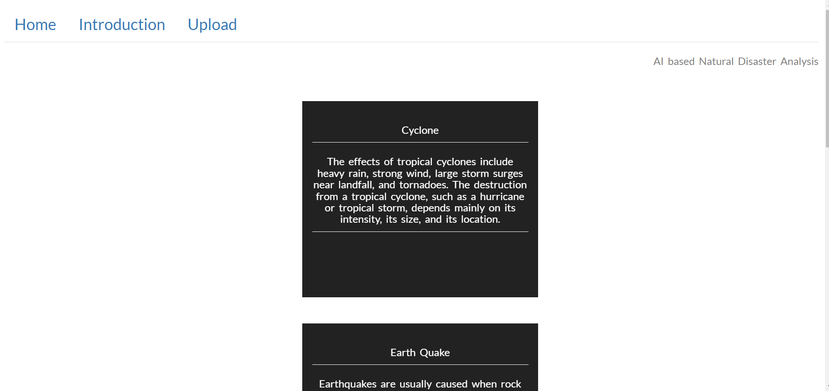

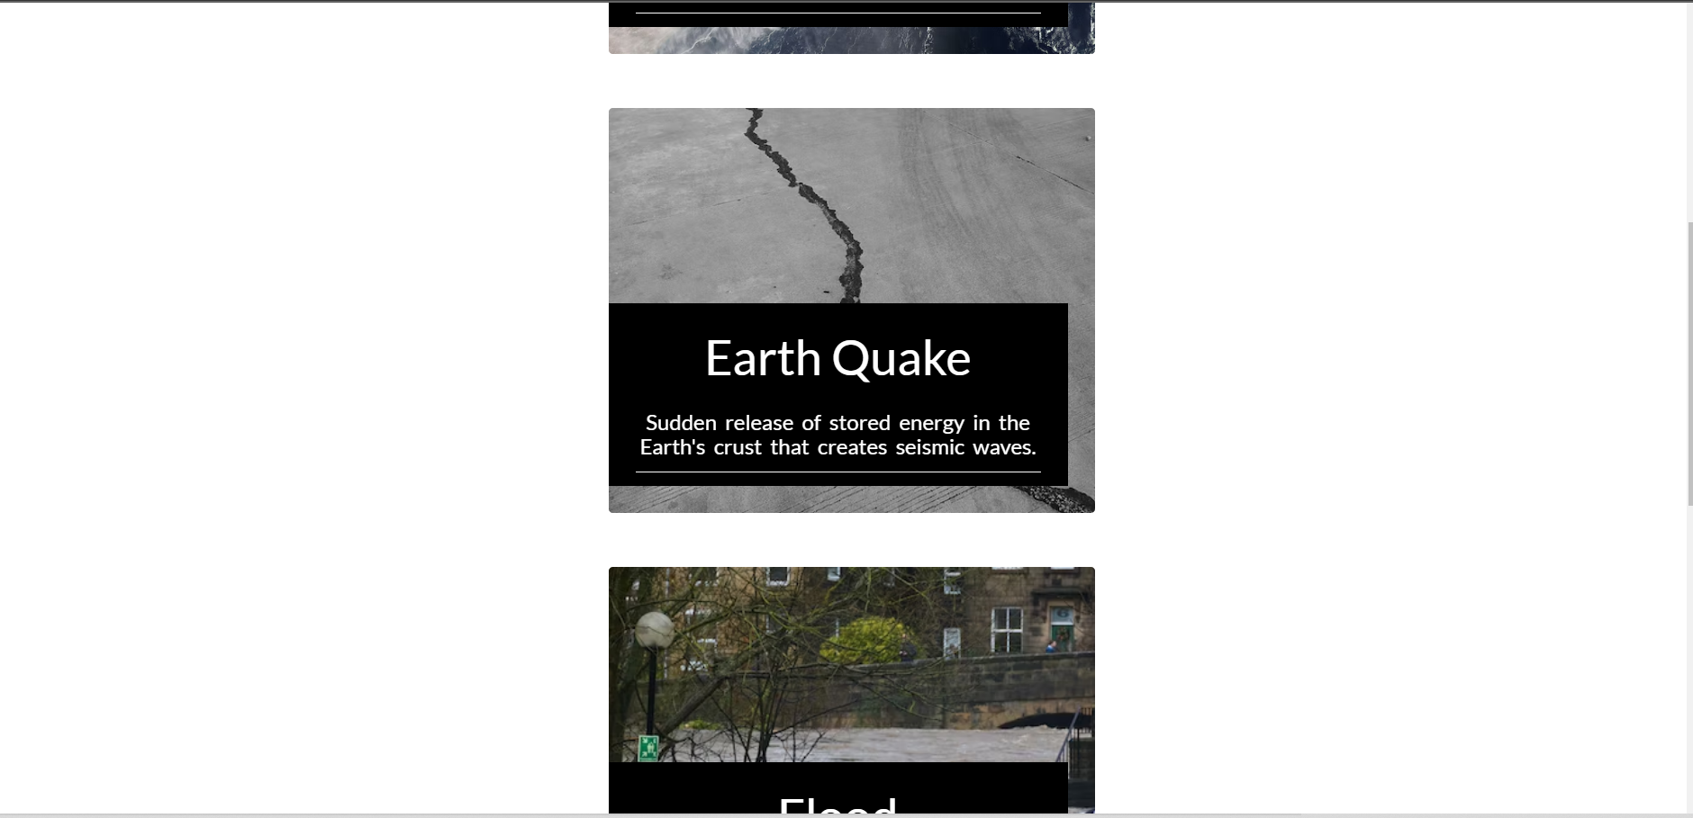

**Intro.html:**

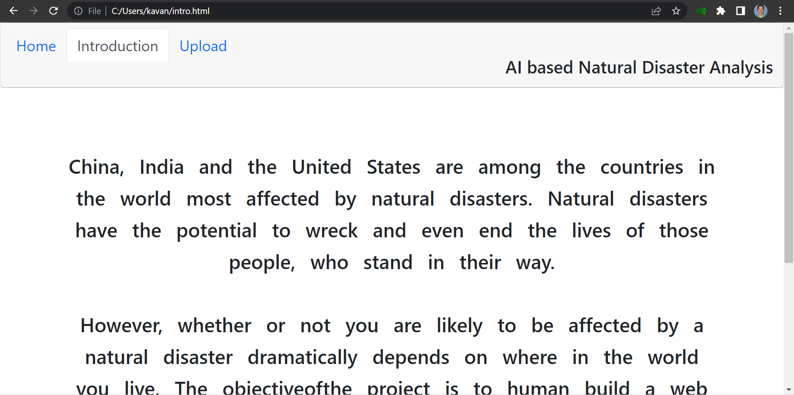

**Upload.html:**

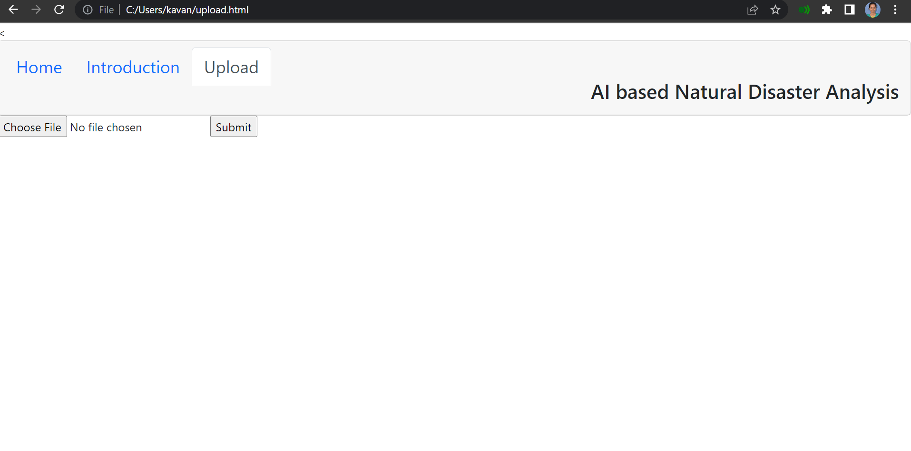

**Flask(application.py):**

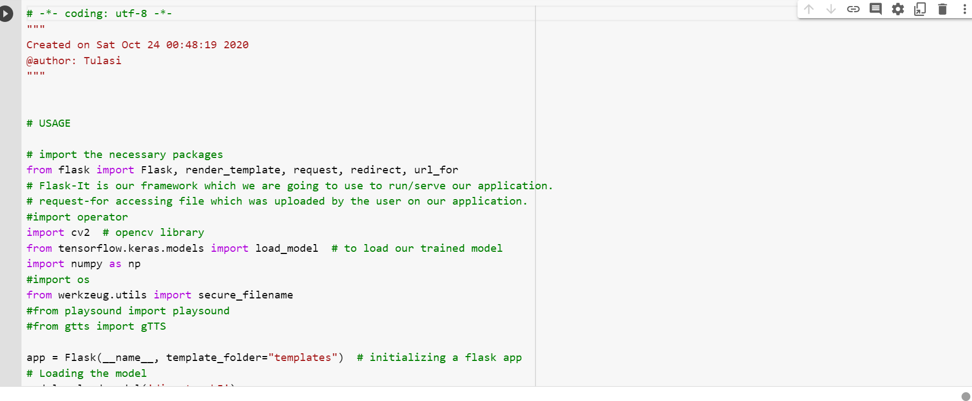

**OUTPUT:**

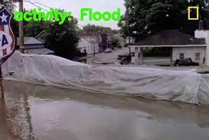

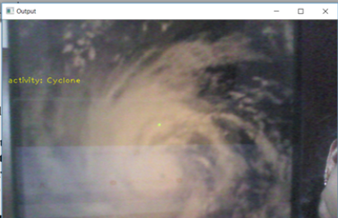

**AI based Natural disaster analysis.ipynb**

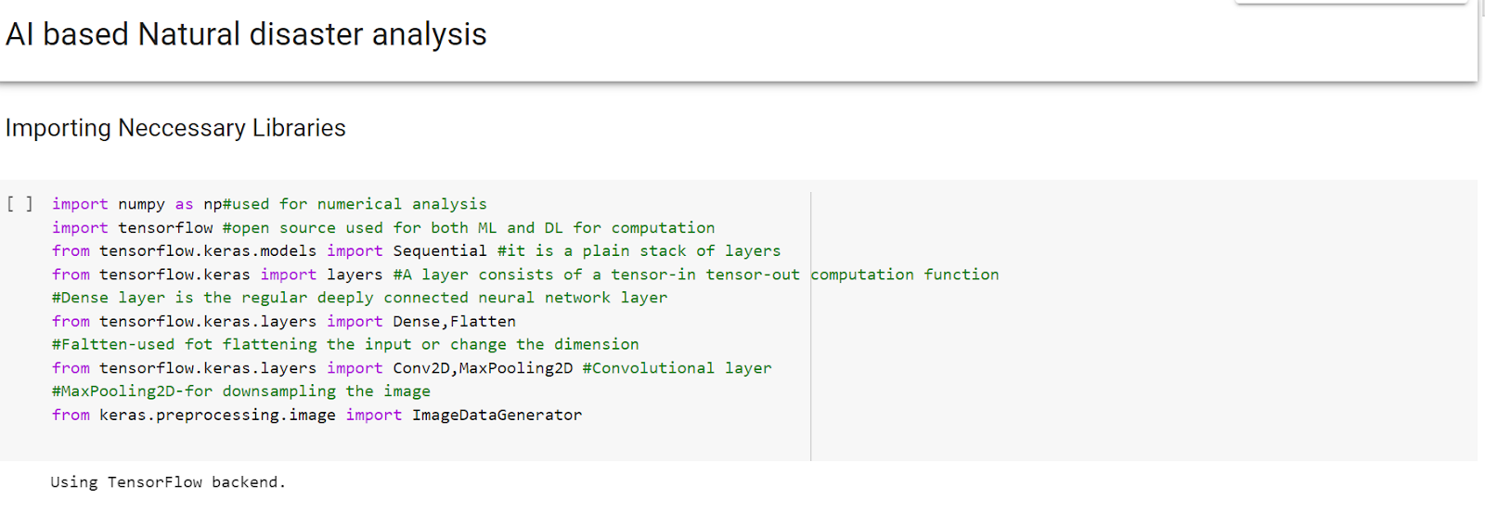

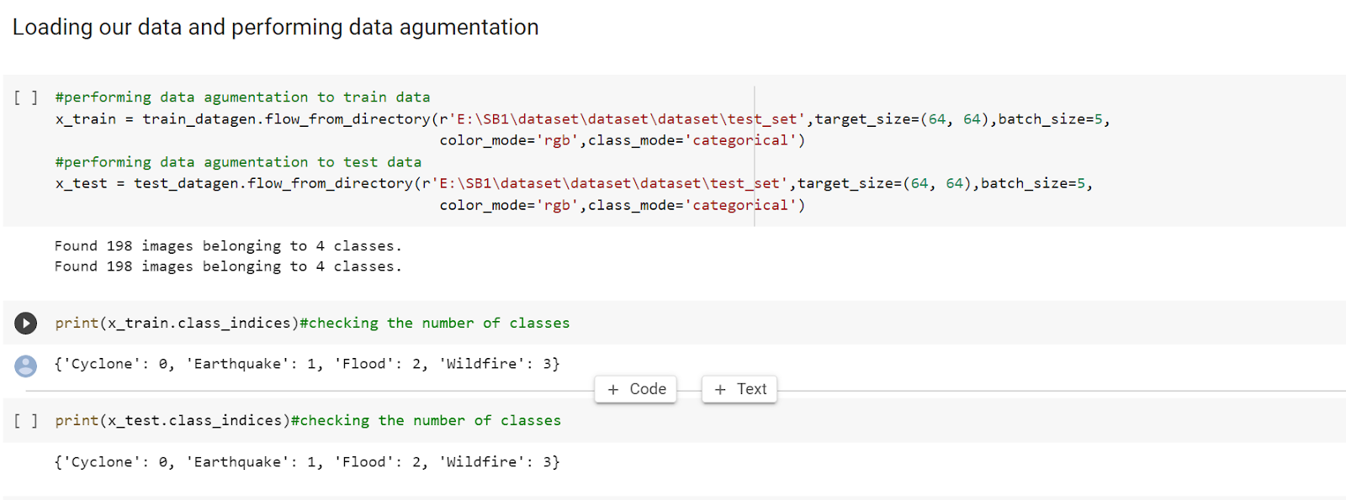

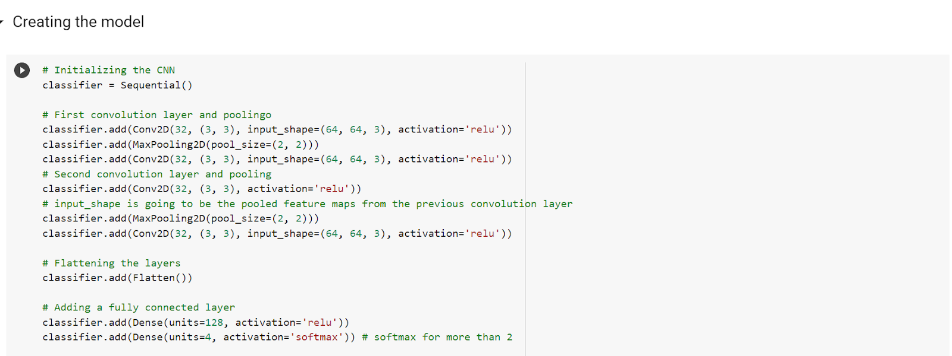

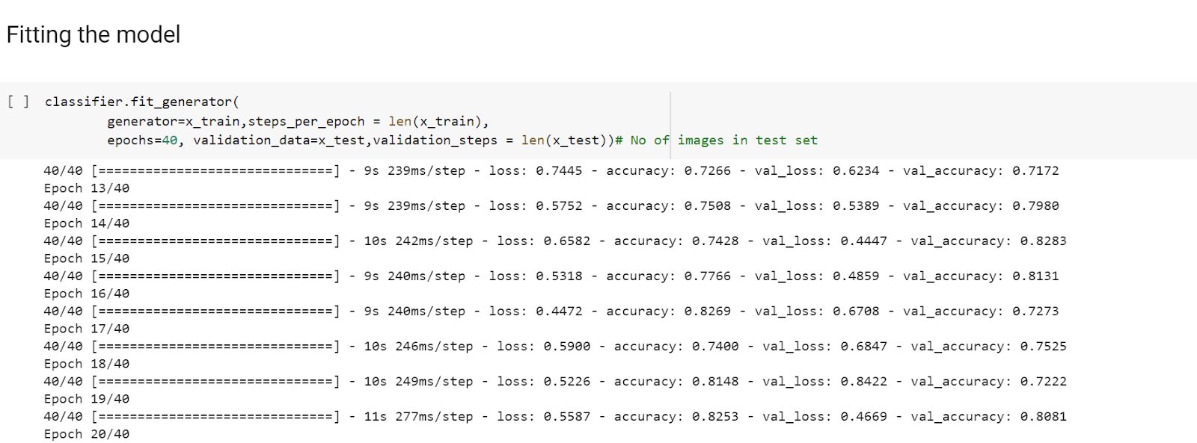

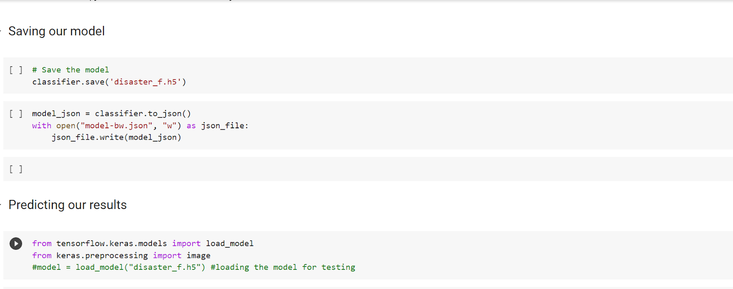

**c_check_earthquake.py:**

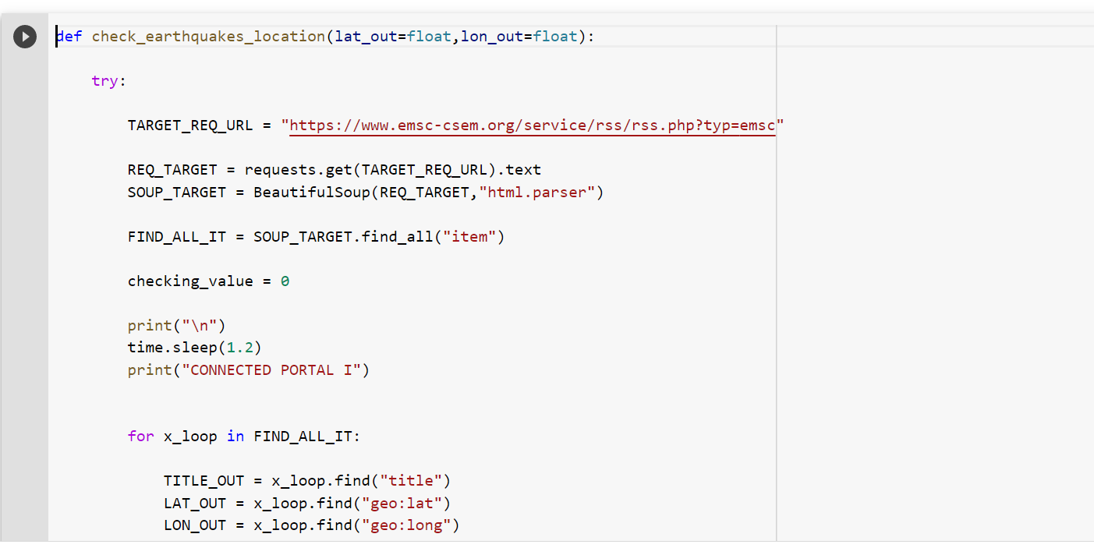

**C_earthquake_g.py:**

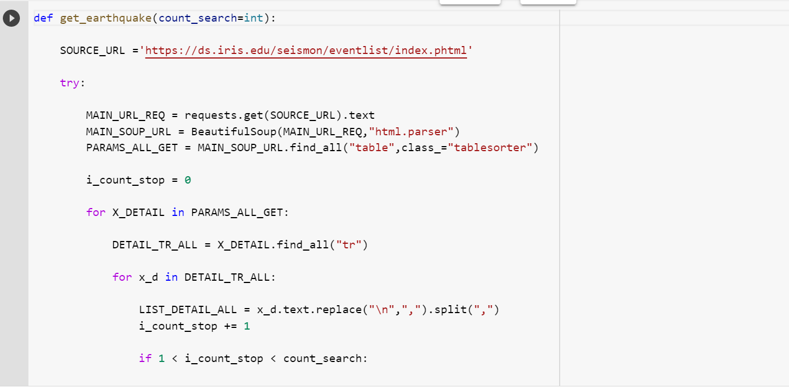

**c_alternative_earthquake.py:**

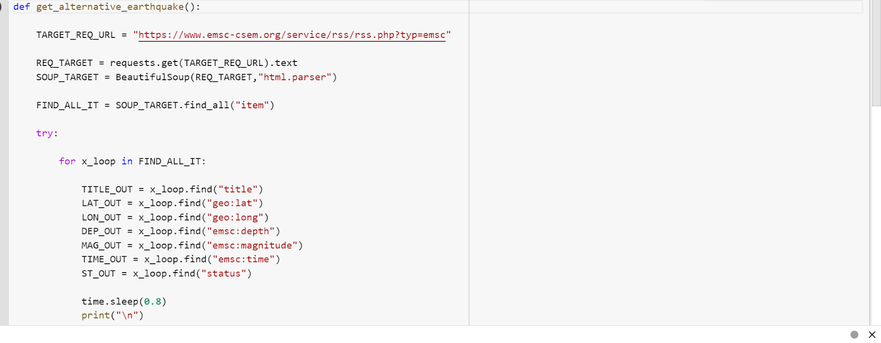

**C_flood.py:**

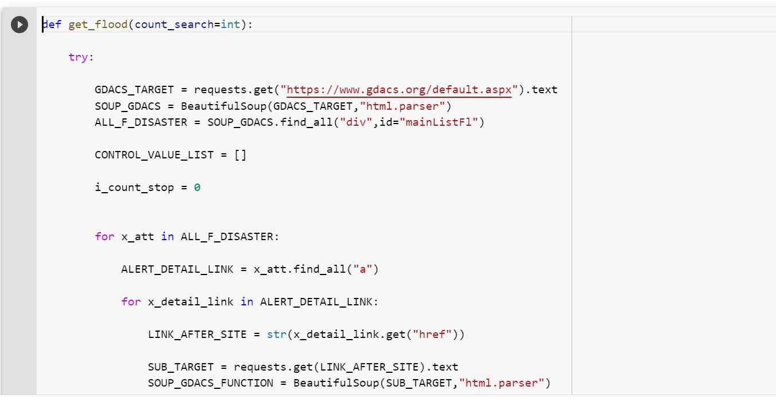

**c_help.py:**

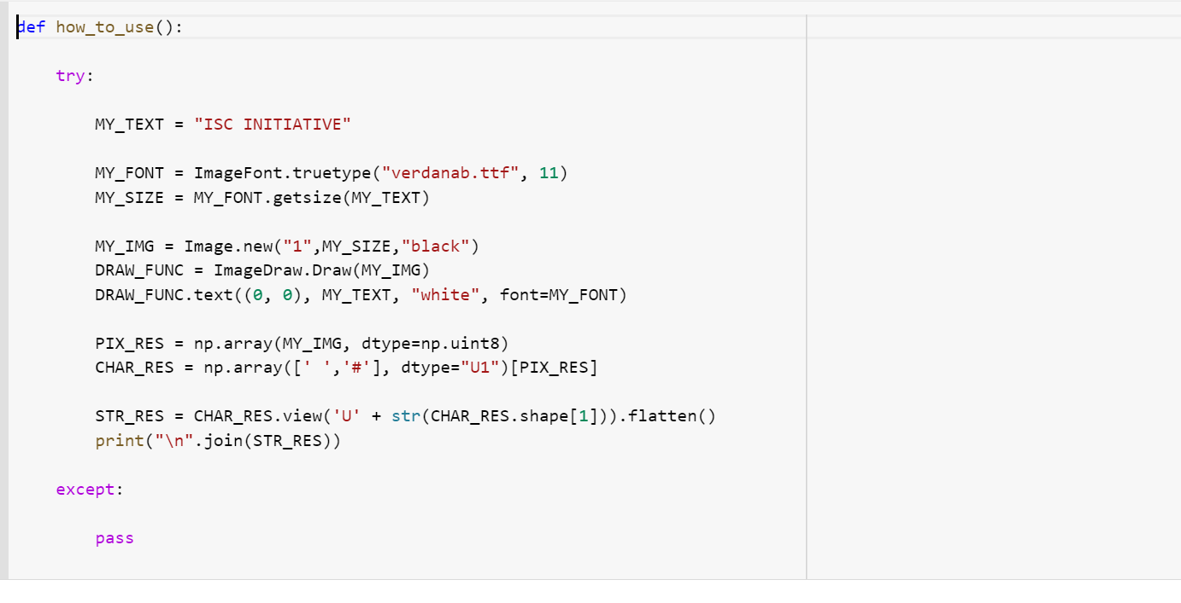

**c_import.py**

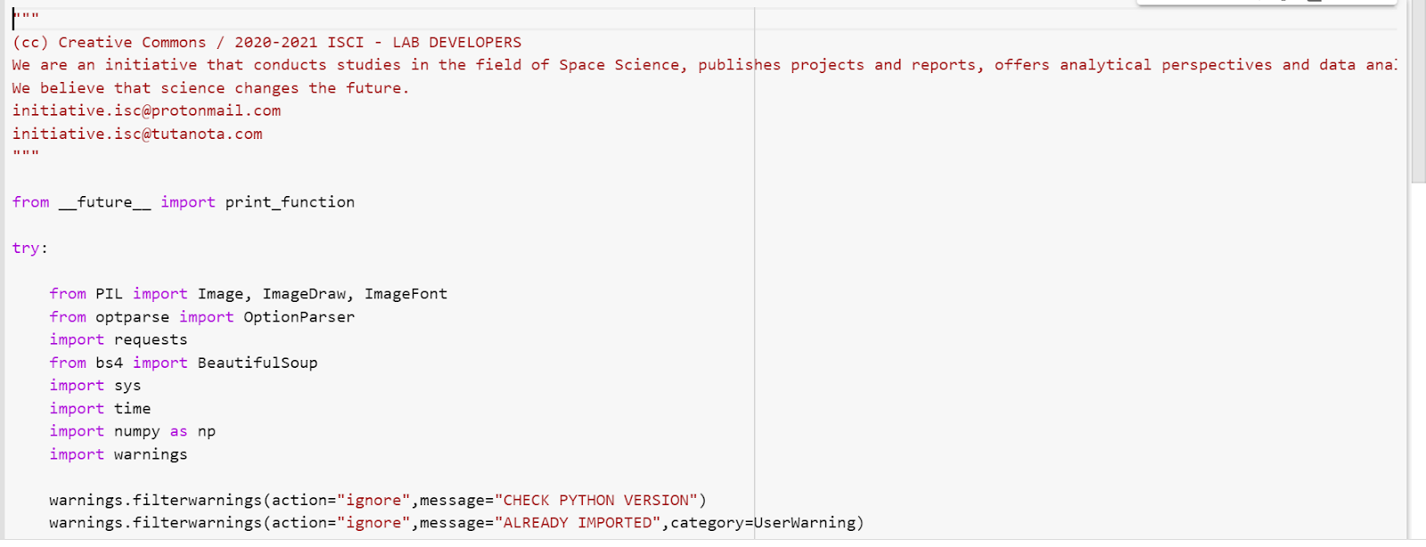

**C_local_alert:**

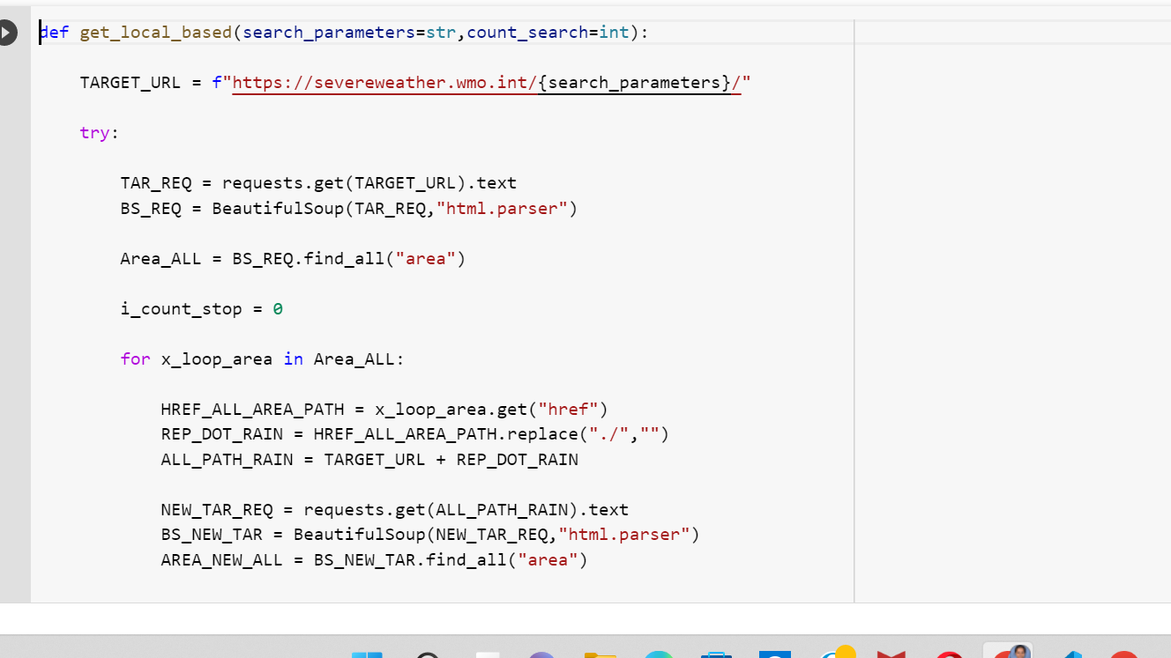

**C_nasaoent.py:**

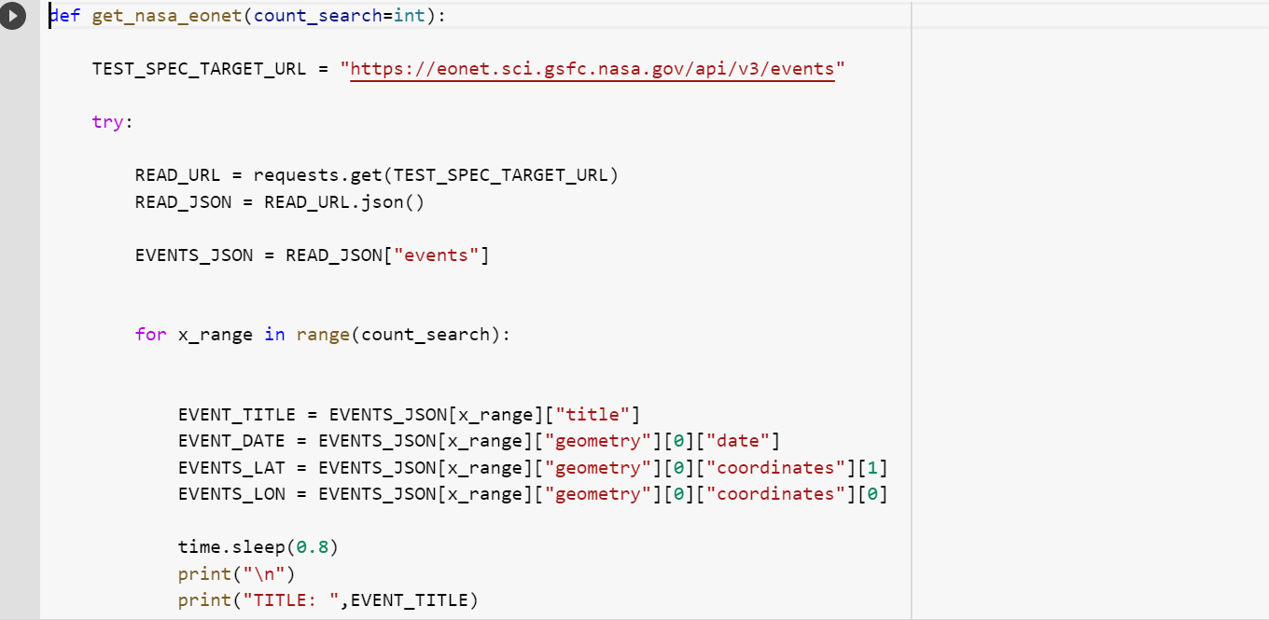

**c_seismic.py:**

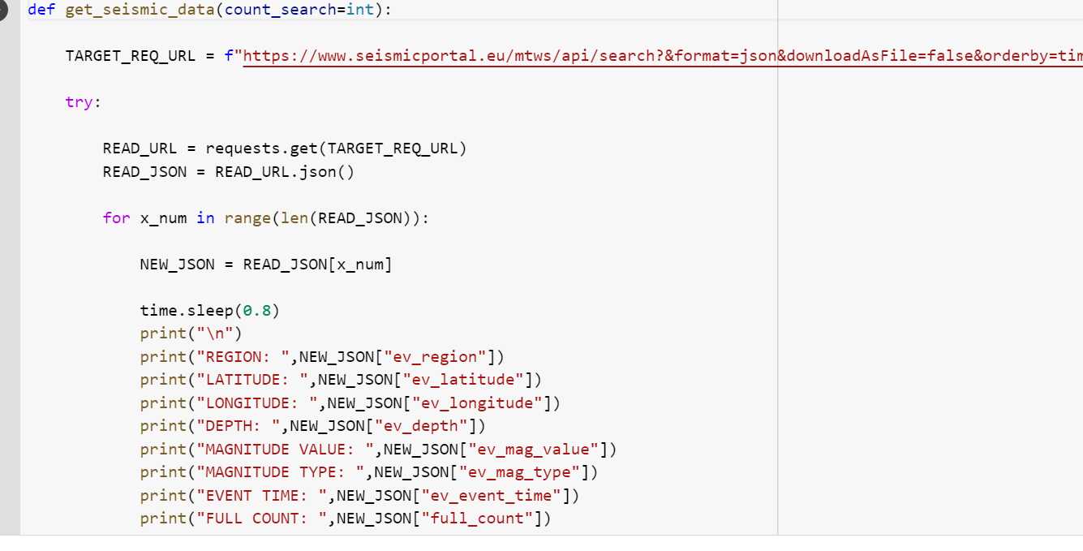

**C_valcano_g:**

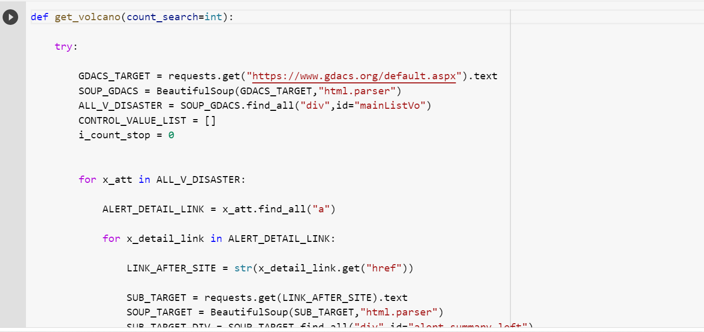

**C_valcano_alternative:**

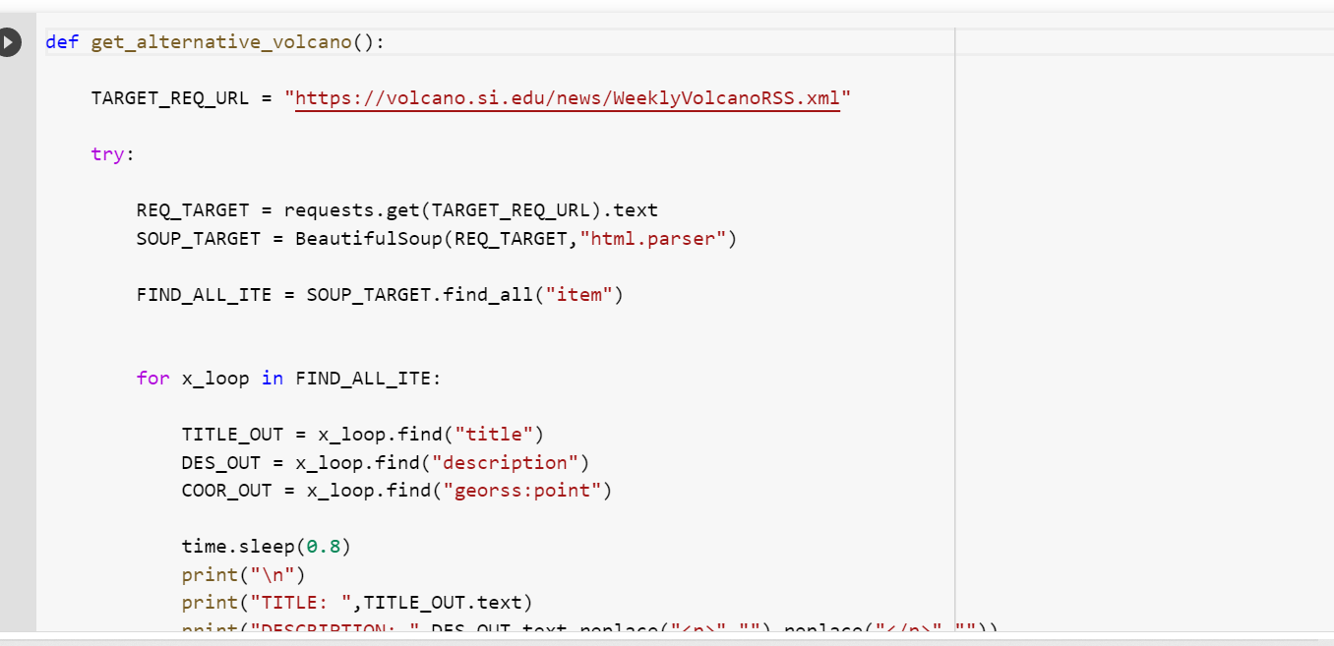

**GITHUB LINK:**

[**https://github.com/IBM-EPBL/IBM-Project-20074-1659711991**](https://github.com/IBM-EPBL/IBM-Project-20074-1659711991)

**DEMOLINK:**

[**https://drive.google.com/drive/folders/1ii8C9eiaVdSPuxS4SO-haW0a-P9nIAH2?usp=share_link**](https://drive.google.com/drive/folders/1ii8C9eiaVdSPuxS4SO-haW0a-P9nIAH2?usp=share_link)